Mapping and associated factors of child death and mothers who suffer from child death in Sub-Saharan Africa.
Bayuh Asmamaw Hailu Master of Public Health in Epidemiology and Bio-statistics, Wollo University, Dessie, Ethiopia.

Abstract
Child death and mothers who suffer from child death are a public health concern in Sub-Saharan Africa. The location and associated factors of child death and mothers who suffer child death were not identified. To monitor and prioritize effective interventions, it is important to identify hotspots areas and associated factors. Data from nationally representative demographic and health survey and Multiple Indicator Cluster administrated in 42 Sub-Sahara Africa countries, which comprised a total of 398,574 mothers with 1,521,312 children. Spatial heterogeneity conducted hotspot regions identified. A mixed-effect regression model was run, and the adjusted ratio with corresponding 95% confidence intervals was estimated. The prevalence of mothers who suffer child death 27% and 45-49 year of age mother 48%. In Niger, 47% of mothers were suffering child death. Women being without HIV knowledge, stunted, wasted, uneducated, not household head, poor, from rural, and from subtropical significantly increased the odds of the case (P<0.05). The spatial analysis can support the design and prioritization of interventions. Multispectral interventions for mothers who suffer from child death are urgently needed, improve maternal health and it will reduce the future risk of cases.
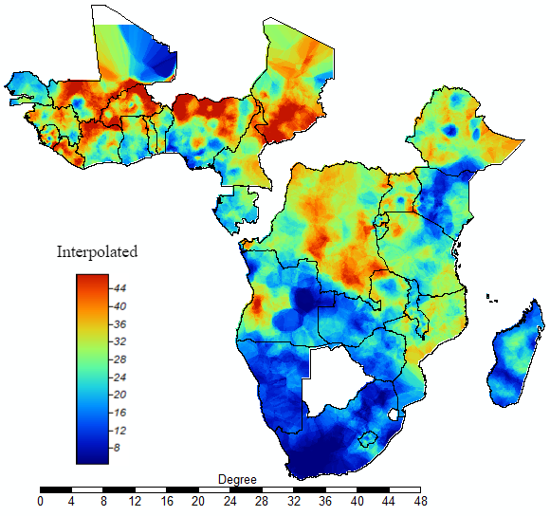
Figure 1. Interpolation of mothers who suffer at least one child death: the interpolated continuous images provided by the interpolation ordinary kriging. The colour through bold blue to bold red indicates an increase in the prevalence of mothers who suffer from child death. Tis analysis was carried out at SAGA GIS
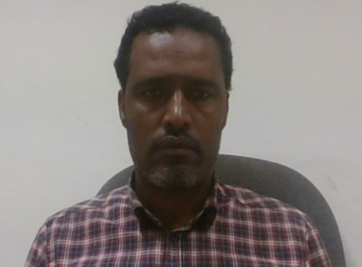Biography
Bayuh Asmamaw Hailu is an Epidemiologist and Biostatistician at Woll University. He has expertise in evaluation and passion in improving the health and wellbeing. His open and contextual evaluation of geographical and non-geographical models based on responsive constructivists creates new pathways for improving health care. He has ample knowledge of different open sources GIS and other statistical soft wear. He used to link his soft wear ability with health and statistics background and experiences, and he can easily show health problems for planners and decision makers as well as any concerned body.

