Abstract Title: (Clinical judgment skills among junior-level nursing students enrolled in adult health nursing courses: Errors and risk level classification)
Hala Mohamed Mohamed Bayoumy¹ * and Gehan Atya Albeladi²
Affiliation (¹Associate Professor of Nursing, Cairo University; Vision Colleges, Saudi Arabia; ² King Faisal Specialist Hospital, Saudi Arabia)

Abstract
As the acuity of patients increases, so does the requirement for nurses who are capable of making proper clinical judgment for safe and quality patients’ care. Assessment of students’ clinical judgment at different stages of their nursing program is thus required. This descriptive cross-sectional study assessed the clinical judgment of 55 junior nursing students using a questionnaire that required participants to rate the severity and perceived risk and identify factors leading to errors described in four vignettes. Participants’ perceptions of the impact of the errors described in the four vignettes differed. However, satisfactory agreement on error risk was evident (the highest rating ranged from 36% to 53.6%). Lack of clinical knowledge and experience and excessive workload were the most commonly identified contributory factors. Many of the junior nursing students in the study showed capability for critical analysis and classifications of error, risks, and associated factors. Based on current study results on error classification, associated risk and potential contributors the overall agreement of the students was moderate. Therefore, there is a need to increase efforts to impart higher clinical judgment skills to students enrolled in nursing education, for which regular longitudinal assessment is required.
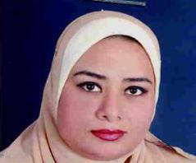

Biography with photo
Associate Professor, Faculty of Nursing, Cairo University, Egypt; Associate Professor, Vision Colleges, KSA; Various Educational Consultation Experiences specifically for New Nursing Colleges Establishments serving as Executive Committee member for establishing the colleges of Nursing in KSAU_HS Eastern region, KSA and New Zarqa University, Jordon; Consultation Experiences specifically for Nursing Curriculum Developments; Strong teaching experiences in muti culture settings. Has extensive research in nursing education and educational technology, quality of life, functional status of adult population, and exploration of impact of different treatment modalities and nursing interventions on biopsychosocial health, self-care and quality of life. Editorial Board Member- for International Journal of Nursing & Clinical Practices. Graphy Publications; Special Issue Editor- Self Care Skills and Quality of Life of Patients - which was published under the International Journal of Nursing & Clinical Practices. Also is a reviewer for multiple journals published under Dove Publications.

Presenting author details
Full name: Hala Mohamed Mohamed Bayoumy
Contact number: 00966549092349
Linked In account : https://linkedin.com/in/dr-hala-bayoumy-a72b3855
Twitter Account
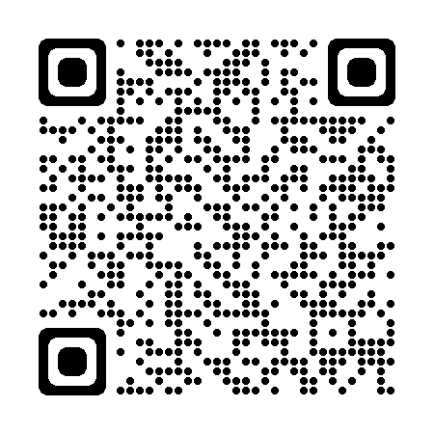 https://mobile.twitter.com/home
@BayoumyHala

Session name/ number:
Presentation type (Oral)

