Title: The global prevalence of maternal near miss: a systematic review and meta-analysis
Name: Sedigheh Abdollahpour
Affiliation: ORC meeting Organizing Committee
1- Sedigheh Abdollahpour: Assistant Professor, PhD in reproductive health, Nursing and Midwifery Care Research Center, Mashhad University of Medical Sciences, Mashhad, Iran.
2-Talat Khadivzadeh: Nursing and Midwifery Care Research Center, Mashhad University of Medical Sciences, Mashhad, Iran. Email: Khadivzadeht@mums.ac.ir
Abstract (upto 300 words)
Background: Improving the maternal health is one of the world’s most challenging problems. Despite significant movements over the past decades, maternal health has been still considered as a central goal for sustainable development. Maternal near miss (MNM) cases experience long-term physical and psychological effects. To present a clear portrait of the current situation, we performed a systematic review and meta-analysis with the purpose to assess the worldwide prevalence of MNM. Methods: We conducted a systematic review on PubMed, Scopus and Web of Science electronic databases to find published papers in English, before March 2019 and regardless of the type of study. We, then, assessed the prevalence of MNM according to the World Health Organization (WHO) criteria. Finally, 49 papers were included in the study. Random effects meta-analysis was used to pool the available prevalence. The quality of studies was also evaluated. Results: The weighted pooled worldwide prevalence of MNM, was 18.67/1000 (95% CI: 16.28- 21.06). Heterogeneity was explored using subgroup analyses based on the continent and the country. We used meta-regression of MNM on MD which resulted in adjusted R-squared as 78.88%. Conclusion: The prevalence of MNM was considerable. Low- and middle-income countries should develop systematic approaches to improve quality of care in the facilities and to reduce the risk of MNM events, with the hope to women’s health
Recent Publications (minimum 5)

- Abdollahpour, Sedigheh, et al. "Global prevalence of maternal mortality ratio in pregnant women infected with coronavirus: A comprehensive review and meta–meta-analysis." International Journal of Healthcare Management 17.2 (2024): 205-214.
- Abdollahpour, Sedigheh, et al. "The Unmet Needs of Women with Maternal Near Miss Experience: A Qualitative Study." Journal of Caring Sciences 13.1 (2024): 63.
- Abdollahpour, Sedigheh, Azam Akbari, and Talat Khadivzadeh. "Novel Memories of Motherhood: Childbirth Lived Experiences of Mothers with Coronavirus Disease 2019 (COVID-19)." Journal of Caring Sciences 12.4 (2023): 248.
- Abdollahpour, Sedigheh, et al. "Determinants of Maternal Near Miss among Women in Northeast Iran: A Facility-Based Case-Control Study." Iranian Journal of Nursing and Midwifery Research 28.3 (2023): 244-249.
- Abdollahpour, Sedigheh, et al. "Death-stricken survivor mother: the lived experience of near miss mothers." Reproductive Health 19.1 (2022): 1-10.
- Abdollahpour, Sedigheh, et al. "Mothering sweetness mixed with the bitterness of death: the lived mothering experience of near-miss mothers." Journal of Psychosomatic Obstetrics & Gynecology (2020): 1-8.
- Abdollahpour, Sedigheh, et al. "Machine learning analysis of the relationships between traumatic childbirth experience with positive and negative fertility motivations in Iran in a community-based sample." Reproductive Health 22.1 (2025): 16.
- Abdollahpour, Sedigheh, et al. "Direct and indirect association of domestic violence against women and severe maternal morbidity: A case–control study." Medicine 104.4 (2025): e41268.

Biography (upto 150 words)

I am Sedighe Abdollahpour. I am an assistant professor at Mashhad University of Medical Sciences. My field of expertise is reproductive health. Most of my research is on maternal morbidities, especially in maternal near miss mothers. The Ph.D. course started on September 23, 2017, and I graduated on June 16, 2021 from Mashhad University of Medical Sciences, Iran. Course Title: Sexual and Reproductive Health.
Dissertation Title: "Death-stricken survivor mother: the lived experience of near miss mothers." Total Average: 19
Email ID: abdollahpourts2@yahoo.com

Presenter Name: Sedigheh Abdollahpour
Type of Presentation: Speaker
Right click on the image to change picture

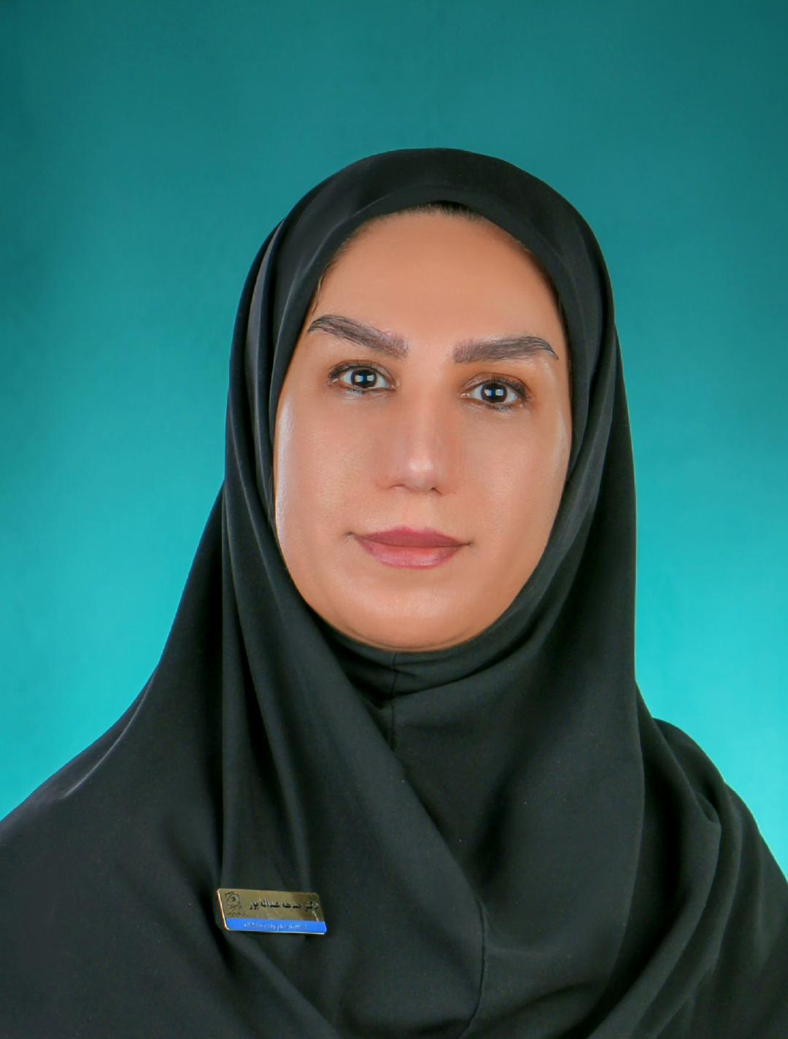
Contact Number: +1 9335742499

