October 30, 2022

Abstract Submission for The 2nd International Conference on Dentistry and Dental Materials
Theme: Innovation and Integration in Dentistry
Author: Shepard DeLong DMD
The Future of Dental Implantology:
The unique Combination of Ceramic Dental Implants and Robotic Surgery
Innovation in dentistry continues in the post-pandemic world at an accelerated rate. The field of implantology is changing rapidly as new materials and protocols are established for success in the replacement of patients’ natural dentition. Ceramic dental implants are now accepted as a safe and viable alternative to implants made of metal. There is now evidence of health risks concerning the use of titanium alloys in dental implants. Ceramics offer some advantages over titanium. Robotics in healthcare and surgical procedures has also seen significant growth, both in the number of systems used throughout the industry as well as the variety of procedures performed utilizing this technology. The first robotic surgical device for the placement of dental implants is now in use within the United States and is facilitating the placement of ceramic implants. This presentation will describe the novel combination of robotic surgery and ceramic dental implants. These two concepts brought together in the practice of modern dental medicine are changing the future of oral health.

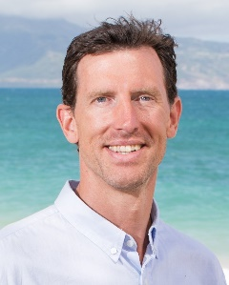 Dr. Shepard DeLong, DMD, is a biological dentist in Portland, Oregon, USA. He holds a BS from Portland State University, DMD from Oregon Health and Sciences University and he completed a GPR at The Queen’s Medical Center in Honolulu, Hawaii. Since 2010, he has been practicing in the western United States and volunteered internationally in India and Guatemala. He is an active member of the IACOI, IAOMT, HDA, IABDM, and ADA, and serves as a mentor for CDOCS. He has been on the forefront of modern dental medicine as former associate at Mint Dental Works, the first LEED certified, hi-tech, eco-friendly practice in the U.S. He is also on staff at Pure Health Dentistry on the island of Maui, Hawaii. He currently maintains a full-time private practice at Lotus Dental Wellness, which he founded in 2017, offering patients biological treatment options to renew and maintain oral health and whole-body wellness. Dr. DeLong has pursued advanced training and has lectured in the United States and abroad on ceramic implantology, lasers and digital dentistry. His latest project has been the combination of robotic surgery and ceramic implantology. He can be reached at drdelong@lotusdentalwellness.com.

