Ventriculomegaly in Costello syndrome

Ramachandran Muthiah

Morning star hospital, Marthandam,
Kanyakumari District, India

Abstract

Costello syndrome is a rare RASopathy resulting from germline mutations of the protooncogene HRAS. Many of these mutations affect SHP2, SOS1, RAS, RAF and MEK proteins It was discovered by Dr. Jack Costello, a New Zealand paediatrician in 1977. Dr. White says. Costello syndrome is now known to be one of a group of related disorders,, caused by abnormal functioning of the Ras‐mitogen‐activated protein kinase (RAS/MapK) pathway. Ras/MAPK pathway is an essential signaling pathway that controls cell proliferation, differentiation, survival and its dysregulation causes clinically overlapping genetic disorders, called as ‘Rasopathies’.In this pathway, Ras, a GTPase, transmits extracellular signaling from receptor tyrosine kinases to two serine/threonine kinases (Raf and MEK) and, finally, to the activation of MAPKs. Costello syndrome is a severe developmental disorder characterised by postnatal growth retardation with delayed skeletal maturation, psychomotor retardation, cutis laxa, and acanthosis nigricans.
Abnormal elastin distribution on tortuous dilated arteries and veins in pulmonary vasculature, causing nonuniform, well thickened, obliterative lesions at arterial branch points leading to early pulmonary hypertensive vascular disease. Structural malformations of the heart present at birth such as valvular pulmonic stenosis and abnormal thickening of the muscular walls of the ventricles (ventriculomegaly). most worrying aspect of the CS phenotype. The features of increased index of suspicion of CS in newborn are fetal atrial tachycardia, increased birth weight and head circumferencw, neonatal hypoglycemia, severe feeding difficulties and urinalysis for hematuria (embryonal rhabdomyosarcoma) and loose, redundant skin on the hands and feet seen in newborns (key role in clinical suspicion of CS). Ras pathway agents, such as farnesyl transferase inhibitors (tipifarnib and lonafarnib) that prevent posttranslational modification of Ras, are being evaluated and may be of therapeutic use for syndromes in this pathway, especially CS. MEK 162 (Binimetinib),orally available inhibitor of mitogen-activated protein kinase kinase 1 and 2 (MEK1/2) ,directly target the RAF-MEK-ERK 1/2 cascade and it is the best tool against cardiac hypertrophy. The most established mTOR inhibitors are so-called rapalogs (rapamycin and its analogs) reverse cardiac defects. Simvastatin- interact with Ras isoprenylation, decrease Ras activity and low dose statin with selective inhibition of pathological ERK 1/2 signaling is an exciting possibility in the reatment of CS patients. RAF-1 inhibition by C-type Natriuretic Peptide (CNP) improved bone growth in preclinical animal models.
Gene correction of these germline mutations to restore normal protein functions is anticipated as a new therapeutic option. This can be achieved through disruption of gain-of-function pathogenic mutation, restoration of loss-of-function mutation, addition of a transgene essential for cell function and single nucleotide changes.
Oxidative stress and free radicals determine non-neoplastic clinical features such as elastin anomalies, alteration of skin and appendages, developmental retardation and cardiac defects. PAR therapy (potassium ascorbate with ribose) a reduction in oxidative stress biomarkers in parallel with improvement of clinical features. It combines the antioxidant action of vitamin C with the stabilizing intracellular effects of potassium and causes improvement of skin and appendage lesions, better evolution of psychomotor development, non progression of heart hypertrophy, nor tumor development. It is low cost, no side-effects and orally administered therapy in rasopathies.

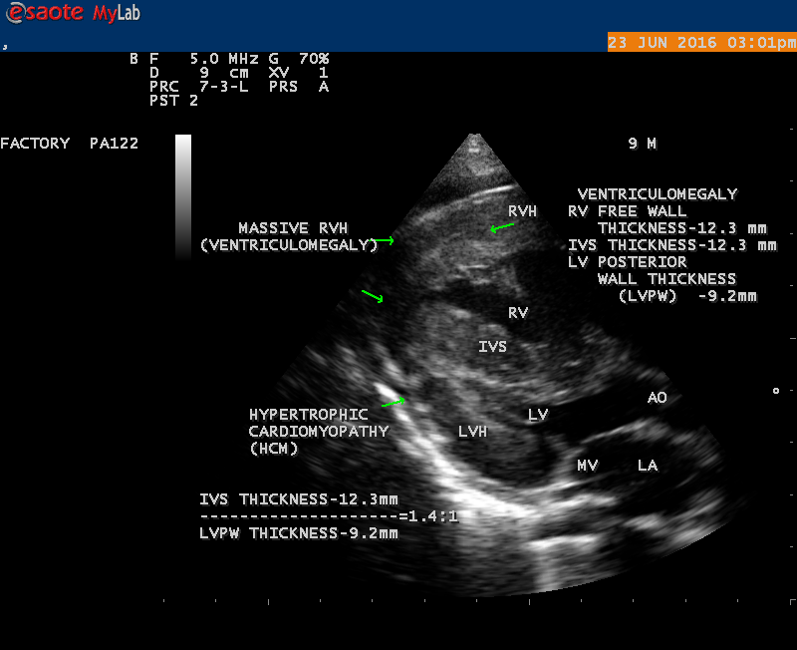

2D Echo- Parasternal long axis view showing massive RVH and HCM (Ventriculomegaly) in a 9 yr old boy
Parasternal long axis view showing HCM (hypertrophic cardiomyopathy) and massive RVH- Ventriculomegaly

Publications
- Muthiah, R. (2021) Isolated Acute Rheumatic Pancreatitis—A Case Report. Case Reports in Clinical Medicine, 10, 52-77
- Muthiah, R. (2019) Infective Endocarditis in Tetralogy of Fallot Complicating Brain Abscess—A Case Report. Case Reports in Clinical Medicine, 8, 105-126
- Muthiah, R. (2018) Native Aortic Valve Endocarditis—A Case Report. Case Reports in Clinical Medicine, 7, 483-504.
- Muthiah, R. (2018) Tropical Coronary Artery Disease and Arrhythmogenic Potentials—The Changing Pattern towards Endomyocardial Fibrosis—An Analysis. Case Reports in Clinical Medicine, 7, 397-429
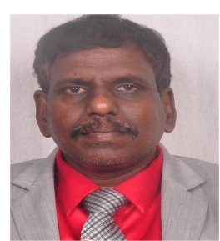
- Muthiah, R. (2018) Isolated Patent Ductus Arteriosus in an Elderly Female, Aged 65 Years—A Case Report. Case Reports in Clinical Medicine, 7, 352-379.

Biography
Ramachandran Muthiah, Consultant Physician & Cardiologist, Zion hospital, Azhagiamandapam and Morning star hospital, Marthandam, Kanyakumari District, India. Born on 10/5/1966.. Mother Swornam belongs to keezhkulam village and Father Muthiah belongs to Enayam thoppu and both were farmers. Published many papers in Cardiosource, American College of Cardiology Foundation, Case Reports in Clinical Medicine (SCIRP) and Journal of saudi heart assocoation.
Name/Address: Ramachandran Muthiah
Palaninta vilai, keezhkulam-629193, kanyakumari district, Tamil nadu state, India
(landline-+914651 203014,
mobile +91 7598755201)
Category: Oral
Passport No:P8925619

