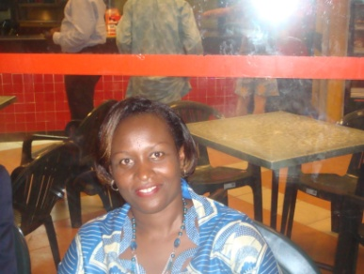
Pr Claudette NDAYIKUNDA, Lecture and Senior Laboratory specialist, PhD, is a Burundian renowned researcher, professor and member of the ASLM team, serving as a member of the East African Public Health Laboratory Network Project operational research
At the university level, she is the Head of the Laboratory at CHU Kamenge Hospital in Bujumbura, which is a University Teaching Hospital of Burundi. The Laboratory is a reference laboratory, and there she performs research on HIV/AIDS, Malaria Covid 19 diseases and microbiology as well as medical research.
She has published more than 50 papers in reputed journals and has been serving as an editorial board member of 3 journals
She is also engaging in surveillance, education and capacity Building in East African community as a deputy chairperson technical working group training and building capacity in Burundi.

