Effect of Two Irrigants on Adaptability of Cross-Linked Gutta-Percha Core

Running title: root canal irrigation solutions in terms of their impact on the sealability and adaptability of cross-linked gutta-percha core to the root canal walls in comparison to thermafil using stereomicroscope and fluid filtration methods.

Nirvana Khalaf Mansour Abdel Hafez
B.D.S. Faculty of Oral and Dental medicine, Cairo University 2009,
Address: Egypt, Suez, mob.no: 00201013225665
Email: dr.nirvana34@gmail.com

Dr. Dalia Moukhtar Fayyad
Professor of Endodontic
Faculty of Dentistry
Suez Canal University

Dr. Ahmed Mostafa Farghaly
Professor of Endodontic
Faculty of Dentistry
Al-Azhar University
The total number of pages: 19
Total number of photographs: 4
Word counts for abstract: 179
Word counts for text: 2665
ABSTRACT
Objective: The objective of this study was to evaluate the effect of two irrigants, Nano silver and QMIX 2IN1 on adaptability and sealability of gutta-core.
Materials and methods: A total number of 120 extracted human straight single rooted premolars were collected. Root canals were cleaned and shaped using crown-down technique to a master apical file size 40. Samples were divided into three groups (n=40) according to the irrigating solution: G1, 5.25% NaOCl; G2, Nanosilver; G3, QMIX 2IN1. Each group was subdivided into two subgroups according to the obturation materials. Subgroup A, Gutta-Core and subgroup B, Thermafil. Stereomicroscope and fluid filtration methods were used to evaluate adaptability and sealability of Gutta-Core and Thermafil. Data was statistically analyzed using one way ANOVA.
Results: Regarding the obturating materials, Gutta-Core showed statistically significantly higher adaptability mean values than Thermafil. Apical level of the root canal showed the highest leakage than middle and coronal levels.
Conclusion: QMIX 2IN1 and Nanosilver irrigants enhances the adaptability of obturating material. Gutta-core is a promising obturating material. Adaptability is a problem with the apical third of root canal.
Key words: Adaptation, Gutta-core, Fluid filtration, Nanosilver, QMix, Stereomicroscope, Thermafil.

INTRODUCTION
The success of endodontic treatment depends mainly on eradication of microbial infection of the root canal system and limitation of the possible re-infection. Chemo-mechanical preparation is an important phase of the root canal treatment [1]. The irrigating solutions have a vital role during and after instrumentation of the root canal system. Sodium hypochlorite (NaOCl) 0.5 – 6% concentration is the most popular irrigating solution that has a potent antimicrobial effect and dissolves the pulpal remnants and collagen [2]. But the weakness of NaOCl includes its cytotoxic effect and inability to remove smear layer that formed during instrumentation [3].
Complete removal of the smear layer demands the use of chelating agents and inorganic solvents like EDTA, Malic acid and Biopure MTAD. Recently QMIX 2in1 irrigating solution has been introduced. It is composed of polyaminocarboxylic acid (chelating agent), bisbiguanide antimicrobial agent (chlorhexidine), surfactant and deionized water. QMIX is able to remove smear layer with ability comparable to that of EDTA [4].
Nano-based materials brought new abilities into different scientific fields. Recently, silver nano-particles (AgNPs) have been applied in many fields because of their broad-spectrum bactericidal properties. AgNPs have high surface-area-to-volume ratio which results in increased reactivity and thereby unique properties. AgNPs solution has been recommended as an alternative to root canal irrigating solutions not only for its strong bactericidal potential but also for its biocompatibility, especially in lower concentrations [5].
Root canal obturation involves the three-dimensional filling of the root canal system and is a critical step in endodontic therapy [6]. Gutta-percha is the most widely used core material but it has disadvantages including lack of rigidity, stiffness and adhesion. Cross linked gutta-percha core is a new core alternative. This cross-linking connects the polymer chains and keeps the gutta-percha from melting, making it subtly stronger while retaining its good features [7].
In the light of the available technologies targeting achievement of successful root canal treatment phases; this study evaluated root canal irrigation solutions in terms of their impact on the sealability and adaptability of cross-linked gutta-percha core to the root canal walls in comparison to thermafil using stereomicroscope and fluid filtration methods.
MATERIALS AND METHODS
One hundred and twenty extracted human straight premolars were collected for this study. Teeth were placed for 15 min. in 5.25% NaOCl for disinfection and to remove surface soft tissue and any debris. Then, they were decoronated with a high speed tapered fissure bur under air water spray so that the length of the root was standardized to 12-14 mm. Patency of each root canal was established by passing size 15 k-file through the apical foramen, specimens were prepared by step-back technique using k-files (Dentsply Maillefer, Switzerland) to a master apical file size 40.
Specimens were classified into 3 groups (n=40) according to the type of the irrigant used as follow: Group 1: teeth were irrigated with 5, 25% NaOCl, Group 2: teeth were irrigated with Nano silver (prepared at Nanotec. company, Egypt), Group 3: teeth were irrigated with QMIX 2in1 (Dentsply Tulsa, USA). Each canal was irrigated according to its group by 5ml irrigant after each file which was delivered through a 25-guage needle, and then dried with paper points.

Specimens of each group were further subdivided into two subgroups (n=20) according to the type of obturating material as follow: Subgroup A; Specimens were obturated with gutta-core (Dentsply, Maillefer, Switzerland), a size 40 gutta core was employed to check whether the carrier reached the full length with-out being forced. Once the fit was verified, then the root canals of each subgroup were coated with a thin layer of Endofill sealer (Dentsply Maillefer, Brazil) with paper point and obturated with gutta-core. Subgroup B; Specimens were obturated with thermafil (Dentsply, Maillefer, USA), with a size 40 or 45 thermafil obturator using the same technique as in subgroup A, but the obturator was heated to 30 seconds in Therma-prep oven.

D- Evaluation of obturation adaptability and sealability:
1-Fluid filtration method:
All specimens were coated totally with a double layer, water proof nail polish in order to seal the superficial cracks in the root structure and prevent fluid extravasation. A plastic tube (3 mm in diameter) was connected to the specimen in an apical direction. All connections in the system were coated with cyanoacrylate adhesive thus providing leak proof connections. Afterwards, pressure of the oxygen tank was raised to force the distilled water to move and displace air out of the apparatus before connecting the plastic tube with the attached specimen to the T-shaped junction. Before measuring the fluid flow rate for each specimen, the system was allowed to equilibrate for 5 minutes. Water was sucked back with the micro-syringe in the second end of the T-shaped junction. In this way, the micro syringe was used to introduce a small air bubble into the apparatus till it reached to the center of micropipette. Finally, O2 from a pressure tank of 15 psi was applied at the apical side and water was forced through the voids along the root-canal filling, displacing the air bubble in the capillary tube by transport of the water. The volume of the fluid transport was measured by observing the movement of this air bubble. The linear movement of the air bubble was measured in millimeters in 3 successive readings at 2 minute intervals. The average of these readings was calculated and the millimeter per minute linear records were converted into micro liters per minute by using this equation [8]:
(V= π r2h)
Where, V is the volume of fluid displacement,
π is the constant 3.14,
r is the radius of micropipette and h is the distant movement of air bubble inside micropipette.
The final data was expressed as μl/ cm H2O/min-1.

2-Stereomicroscope:
The same specimens used in fluid filtration test were subjected to cross sectional analysis. The roots were cross-sectioned horizontally at 3, 6 and10 mm from the apex with the help of double sided diamond disk resulting in 3 sections; apical, middle and coronal for each root. Each section was positioned on the digital stereomicroscope (Scope Capture Digital Microscope, China) and photographed under identical magnification (×40). These photographs were transferred to a personal computer and analyzed using Image tool software (Image J software, USA). Images were analyzed based on the presence of voids; the ratio of void areas to the total filled root canal area was calculated and reported as percentage. After that a collective value was taken for each sample by calculating the average of apical, middle and coronal values to correlate them with fluid filtration results.

Statistical analysis:
Data were tabulated and explored for normality by checking the data distribution, calculating the mean and median values using Kolmogorov-Smirnov and Shapiro-Wilk tests. Data showed non-parametric distribution so, Kruskal-Wallis test was used for comparisons between the three irrigants. Mann-Whitney U test with Bonferroni’s adjustment was used for pair-wise comparisons when Kruskal-Wallis test is significant. Mann-Whitney U test was also used for comparisons between the two obturation materials. Friedman’s test was used for comparisons between the three root levels. Wilcoxon signed-rank test with Bonferroni’s adjustment was used for pair-wise comparisons when Friedman’s test is significant.
The significance level was set at P ≤ 0.05. Statistical analysis was performed with IBM® SPSS® Statistics Version 20 for Windows.

RESULTS
- I. Comparison between irrigants:
        - Subgroup A: specimens obturated with Gutta-Core

According to fluid filtration test, there was no statistically significant difference between Nano-Silver and QMix. Both showed a statistically significant lower mean volume of fluid transport/minute (vol/min) than NaOCl that showed the statistically significant highest mean volume/minute (P-value= 0.012). Results of stereomicroscopic test, showed the same results of fluid filtration test at three root canal levels and collectively. (Table 1,2. Fig.1,2,3).

Subgroup B: specimens obturated with Thermafil
It showed the same results of gutta-core according to fluid filtration and stereomicroscopic test, collectively and at apical and coronal levels. But at the middle level of root canal, no statistically significant difference between NaOCl and QMix. Both showed a statistically significant higher mean of voids % than Nano-silver that showed the statistically significant lowest mean of voids % (P- value= 0.018). (Table 1,2. Fig. 1,2,4).
Table (1): Mean and standard deviation (SD) values of volume transport/minute of the two obturation materials with different irrigating solutions using fluid filtration test
Irrigant  Material | Nano-Silver | QMix | NaOCl | P-value
Gutta-Core | 1.31 (0.23) | 1.23 (0.46) | 1.82 (0.66) | 0.021*
Thermafil | 1.19 (0.27) | 1.44 (0.46) | 1.87 (0.30) | 0.023*
P-value | .009* | 0.013* | .015*
*: Significant at P ≤ 0.05.
Table (2): Mean and standard deviation (SD) values of voids % of the three irrigants using stereomicroscopic test
Material | Irrigant  Root level | Nano-Silver | QMix | NaOCl | P-value
Gutta-core | Coronal | 0.67 (.45) ^{b} | 0.43 (.53) ^{b} | 1.35 (1.00) ª | 0.025*
Gutta-core | Middle | 0.78 (.50) ^{b} | 0.97 (.68) ^{b} | 1.097 (.89) ª | 0.018*
Gutta-core | Apical | .82 (.54) ^{b} | 0.81 (.49) ^{b} | 1.21 (.62) ª | 0.003*
 | Collectively | .76 (.49) ^{b} | .74 (.57) ^{b} | 1.23 (.84) ª | 0.046*
Thermafil | Coronal | 0.97 (.69) ^{b} | 0.87 (.39) ^{b} | 1.13 (.81) ª | 0.025*
Thermafil | Middle | 0.78 (.39) ^{b} | 1.27 (.51) ª | 1.44 (.52) ª | 0.018*
Thermafil | Apical | 1.05 (.35) ^{b} | 1.12 (.44) ^{b} | 1.47 (.74) ª | 0.006*
 | Collectively | 1 (.58) ^{b} | 1.09 (.45) ^{b} | 1.35 (2.07) ª | 0.016*
*: Significant at P ≤ 0.05, Different superscripts in the same row are statistically significantly different

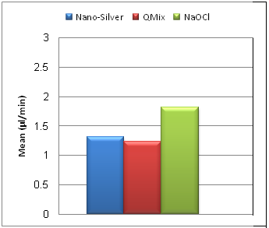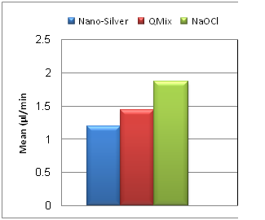
GuttaCore Thermafil
Figure (1): Bar chart representing mean volume transport/minute of the three irrigants after obturation with GuttaCore and Thermafil

Figure (2): Bar chart representing mean voids % of the three irrigants after obturation with GuttaCore and Thermafil
Subgroup A: Gutta-core
Coronal Middle Apical
QMix | 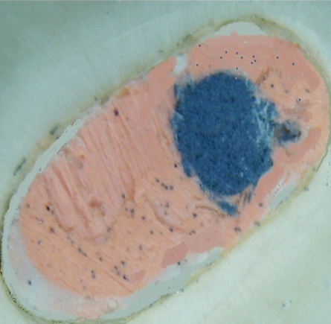 | 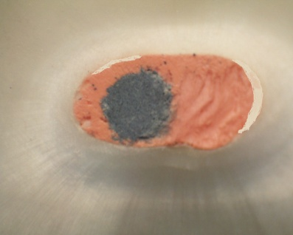 | 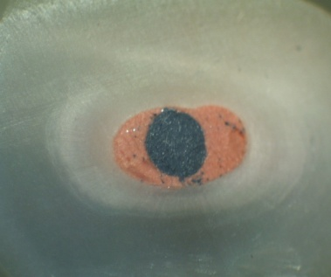
Nano-silver | 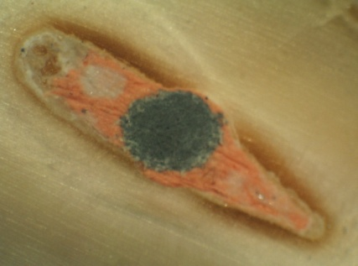 | 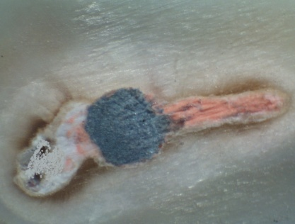 | 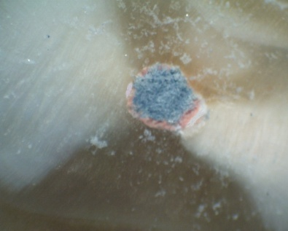
NaOCl | 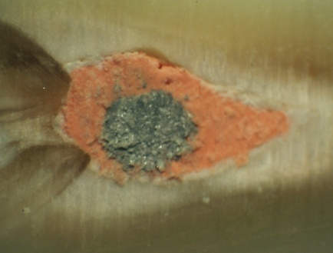 | 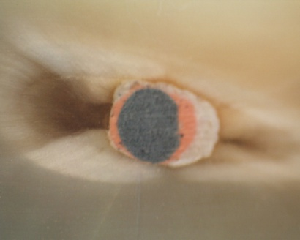 | 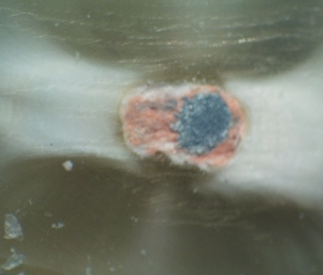
Figure (3): A Stereomicroscopic digital images at different root canal levels obturated with Gutta-core at 40X magnification

Subgroup B: Thermafil
Coronal Middle Apical
QMix | 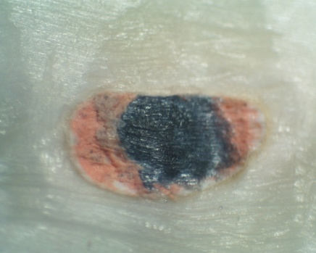 | 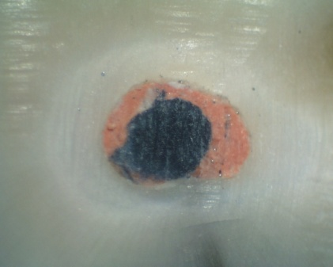 | 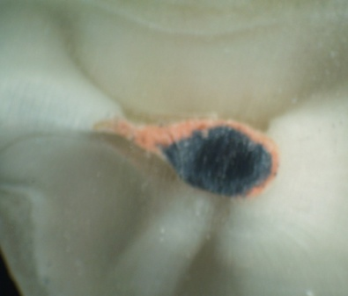
Nano-silver | 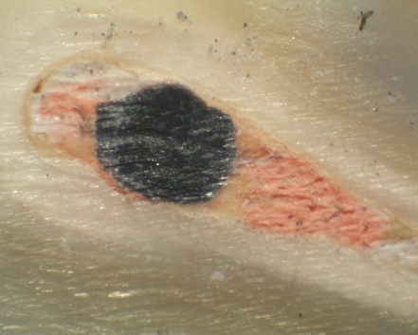 | 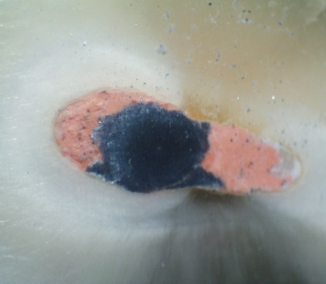 | 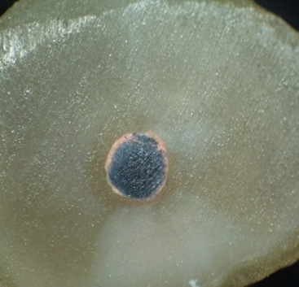
NaOCl | 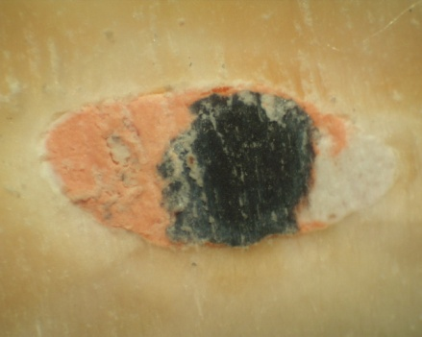 | 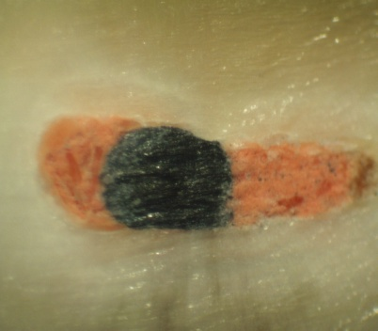 | 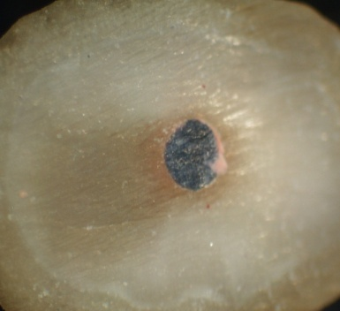
Figure (4): A Stereomicroscopic digital images at different root canal levels obturated with Thermafil at 40X magnification
- Comparison between voids % at different root canal levels

Regarding the specimens obturated with gutta-core, There was no statistically significant difference between root canal levels for all irrigants, except for QMIX, the apical level showed the statistically significant highest mean of voids % than the coronal and middle (P-value = 0.04), Table (3), Fig.(3).
Regarding the specimens obturated with Thermafil, both QMix and NaOCl, recorded a lower mean of voids % in the coronal level than middle and apical levels. While with Nano-Silver there was no statistically significant difference between root canal levels, Table (3), Fig.(3).

Table (3): Mean, standard deviation (SD) values and results of comparison between voids % at different root levels
Irrigant | Root level  Material | Coronal | Middle | Apical | P-value
Nano-Silver | Gutta-core | 0.67 (.45) ª | 0.78 (.50) ª | .82 (.54) ª | 0.075
Nano-Silver | Thermafil | 0.97 (.69) ª | 0.78 (.39) ª | 1.05 (.35) ª | 0.207
QMix | Gutta-core | 0.43 (.53) ^{b} | 0.81 (.78) ^{b} | 0.97 (.89) ª | 0.04*
QMix | Thermafil | 0.87 (.39) ^{b} | 1.27 (.51) ª | 1.12(.44) ª | 0.03*
NaOCl | Gutta-core | 1.35 (1.0) ª | 1.097 (.89) ª | 1.21 (.62) ª | 0.674
NaOCl | Thermafil | 1.13 (.81) ^{b} | 1.44 (.52) ª | 1.47 (.74) ª | 0.02*
*: Significant at P ≤ 0.05, Different superscripts in the same row are statistically significantly different
- Comparison between obturation materials

Regarding the results of fluid filtration test, GuttaCore showed statistically significant lower mean value of volume transport/minute than Thermafil after irrigation with Nano-Silver, QMIX and NaOCl (Table 1). Regarding the results of stereomicroscopic test, GuttaCore also showed statistically significant lower mean value of voids % at coronal, apical levels and collectively, after irrigation with Nano-Silver and QMIX. While after irrigation with NaOCl, the only statistically significant difference was at the middle level, (Table 4).

Table (4): Mean, standard deviation (SD) values and results of comparison between voids % of the two obturation materials
Irrigant | Root level  Material | Coronal | Middle | Apical | Collectively
Nano-Silver | Gutta-core | 0.67 (.45) ª | 0.78 (.40) ª | .82 (.54) ª | .76 (.49) ª
Nano-Silver | Thermafil | 0.97 (.69) ^{b} | 0.78 (.39) ª | 1.25 (.65)^{b} | 1 (.58) ^{b}
Nano-Silver | P-value | 0.006* | 0.096 | 0.008* | 0.034*
QMix | Gutta-core | 0.43 (.53) ª | 0.97 (.68) ª | 0.81 (.49)ª | 0.74 (.57) ª
QMix | Thermafil | 0.87 (.39) ^{b} | 1.27 (.51) ª | 1.12 (.44)^{b} | 1.09 (.45) ^{b}
QMix | P-value | 0.16* | 0.075 | 0.008* | 0.028*
NaOCl | Gutta-core | 1.35 (1.0) ª | 1.09 (.89) ª | 1.21 (.62) ª | 1.23 (.84) ª
NaOCl | Thermafil | 1.13 (.81) ª | 1.44 (.52) ^{b} | 1.47 (.74) ª | 1.35 (2.07) ª
NaOCl | P-value | 0.176 | 0.042* | 0.052 | 0.076
*: Significant at P ≤ 0.05

DISCUSSION
Results of the present study revealed that, root canals treated with Nanosilver and Qmix irrigants almost revealed statistically significant more adaptability and less leakage than NaOCl. This may be attributed to the fact that Qmix irrigant is able to remove the smear layer. So that when the surface area of dentin exposed to the obturating material is increased, the adhering and penetrating capacity of this material is improved and a better seal is expected [8]. Also, QMix favours wetting of the root canal dentin by the sealer, resulted in small contact angle produced on dentin causing intimate contact of the sealer with the dentin surface. This may increase adaptability of obturating material and penetration of sealer into the dentinal tubules [9]. These findings were also in agreement with Elnaghy [8] and ballal et al. [10].
Nanosilver irrigant consists of nano-sized silver particles. This size increases the surface area to volume ratio, thereby increases the reaction between nano-particles and the target surface [11]. Also its ability to dissolve and neutralize soft pulpal tissue, remove the organic portion of smear layer, letting nanosilver particles to penetrate deeper into dentinal tubules and narrow spaces beyond the reach of instruments [12]. Gutta-core showed better adaptation and improved sealing ability than thermafil. Even when there was no significant difference in some groups, it produced more adaptability. This might be attributed to that, gutta-core obturator carriers are made from a gutta-percha elastomer with intermolecular cross-links (peroxide) [7]. Thus, the obturator is made entirely of gutta-percha in two different forms. Also, Gutta-core carrier appeared to offer better micromechanical retention than the thermafil carrier, since the gutta-core carrier is crosslinked gutta-percha [13, 14] and so it is unlikely that any chemical interaction would develop between this and the alpha-phase gutta-percha of the coating so that avoid stripping of gutta-percha from the carrier during the insertion into the root canal space. This would result in reducing voids and adequate filling of the root canal space [15]. These findings were in agreement with other studies [14, 16, 17] which reported that gutta-core demonstrated significantly higher bond strength than thermafil.
On the other hand, the lower sealing ability of thermafil might be related to anatomic variability of teeth that may cause striping of gutta-percha from carrier surface during insertion. That results in more voids and leakage [18, 19]. Also, it may be due to twisting the carrier during insertion into the root canal and inadequate amounts of sealer placed prior to insertion of the obturators in the root canal [20]. These findings were in agreement with Levitan et al. [21]. Although in disagreement with Smajkic et al. [22] and Mancino et al., [23] they stated that Thermafil has shown satisfactory results of apical leakage and acceptable obturation of root canals. Variations in canal anatomy in extracted teeth, limited number of the samples with different evaluation methods might be the reason for such variation.
Results of comparison between different root canal levels revealed that apical level showed statistically significant highest leakage with gutta-core obturating material than middle and coronal. This might be due to morphological complexity of the apical part of the root canal as it is known for its variability and unpredictability [24, 25]. These findings were in agreement with many studies [26, 27], but also in disagreement with others [28, 29]. These differences might be due to; change in the root length, final size of canal preparation, and using stratified sampling, or due to different adaptability test, spiral computed tomography.
Under the limitation of this study, the following conclusions can be drawn:
- QMIX 2IN1 and Nanosilver irrigants enhanced favorable adaptability.
- The gutta-core showed better adaptability than thermafil.
- The apical level of the root canal showed the highest leakage while coronal level showed the lowest one.

Financial support and sponsorship
Self-funded.

Conflicts of interest
There are no conflicts of interest.

REFERENCES
- Rubin L., Skobe F., Krakow A., Gron P, 1993. The effect of instrumentation and flushing of freshly extracted teeth in endodontic therapy: a scanning electron microscope study. J Endod. 5:328–335.
- Roger MC., Alex JM, 1998. Sodium hypochlorite and its use as an endodontic irrigant. Aust Dent J. 43:128-130.
- Haapasalo H., Siren E., Waltimo T, 2000. Inactivation of local root canal medicaments by dentin: an in- vitro study. Int Endod J. 33:126–131.
- Stojicic S., Shen Y., Qian W., Johnson B., Haapasalo M, 2011. Antibacterial and smear layer removal ability of a novel irrigant, QMix. Int Endod J. 45:363–371.
- Moghadas L., Shahmoradi M., Narimani T, 2012. Antimicrobial activity of a new nano based endodontic irrigation solution: In vitro study. Dent Hypotheses. 3:142-146.
- Gutmann JL, 1992. Clinical, radiographic, and histologic perspectives on success and failure in endodontics. Dent Clin North Am. 36:379-392.
- Marques-Ferreira M., Abrantes M., Ferreira HD., Caramelo F., Botelho MF. and Carrilho, EV., 2017. Sealing efficacy of system B versus Thermafil and Guttacore obturation techniques evidenced by scintigraphic analysis. J clin experim dent. 9, p.56.
- Elnaghy M, 2014. Effect of QMix irrigant on bond strength of glass fibre posts to root dentin. Int Endod J. 47:280 - 289.
- Chandra S, Shankar P, Indira R, 2012. Depth of penetration of four resin sealers into radicular dentinal tubules: a confocal microscopic study. J Endod. 38:1412–1416.
- Ballal N., Tweeny A., Khechen K., Prabhu N., Satyanarayan K., Franklin R.2013. Wettability of root canal sealers on intraradicular dentin treated with different irrigating solutions. J dent. 6:556-560.
- Doty C., Tshikhudo R., Brust M., Fernig D, 2005. Extremely stable water-soluble Ag nanoparticles. J Chem Mater. 17:4630-4635.
- Estrela C., Barbin E., Spanó J., Marchesan M., Pecora J, 2002. Mechanism of action of sodium hydroxide. Braz Dent J. 13:113-117.
- Tilakchand M, Jain A, Naik B, 2016. Expansion of gutta-percha in contact with various concentrations of zinc oxide-eugenol sealer: a three-dimensional volumetric study using spiral computed tomography, J Conserv Dent 19:4, pp. 317-322.
- Alhashimi R., Foxton R., Romeed S., Sanjukta D, 2014. An in vitro assessment of gutta-percha coating of new carrier-based root canal fillings. Scient World J. 11:55-62.
- Yadav, S., Nawal, R.R., Chaudhry, S. and Talwar, S., 2020. Assessment of Quality of Root Canal Filling with C Point, Guttacore and Lateral Compaction Technique: A Confocal Laser Scanning Microscopy Study. Euro Endod J. 5, 236-241.
- Weller RN., Kimbrough WF., Anderson RW, 1997. A comparison of thermoplastic obturation techniques: adaptation to the canal walls. J Endod. 23: 703–706.
- Li GH, Niu LN, Selem LC, Eid AA, Bergeron BE, Chen JH, Pashley DH, Tay FR, 2016. characteristics of carrier-based techniques vs. single cone technique in curved root canals. Clin Oral Invest. 20:1631-1637.
- Vula, V., Ajeti, N., Kuçi, A., Stavileci, M. and Vula, V., 2020. An in vitro comparative evaluation of apical leakage using different root canal sealers. Medic Scien Monit Basic Res. 26, pp.e928175-1.
- Schafer E, Schrenker C, Zupanc J, Burklein S, 2016. Percentage of gutta-percha filled areas in canals obturated with cross-linked gutta-percha core-carrier systems, single-cone and lateral compaction technique. J Endod. 42:294-298.
- DuLac K., Nielsen C., Tomazic T., Ferrillo P., Hatton F, 1999. Comparison of the obturation of lateral canals by six techniques. J Endod. 25:376– 380.
- Levitan M., Himel V., Luckey B, 2003. The effect of insertion rates on fill length and adaptation of a thermoplasticized gutta-percha technique. J Endod. 29:505– 508.
- Smajkic N., Prcic A., Konjhodzic –Rascic H, 2009. Quantification of apical leakage on root canals filled by different techniques (In Vitro). Materia Sosio Medica. 21: 27-30.
- Mancino D., Kharouf N., Cabiddu M., Bukiet F. and Haïkel Y., 2020. Microscopic and chemical evaluation of the filling quality of five obturation techniques in oval-shaped root canals. Clin oral investigation.1-9.
- Vertucci F, 2005. Root canal morphology and its relationship to endodontic procedures, Endod Topics. 10:3–29.
- Franklin RT., Robert JL., Norman RW., Kimbrough WF, 2005. Ultra-structural evaluation of the apical seal in roots filled with a polycaprolactone-based root canal filling material. J Endod. 31:514- 519.
- Stratul S., Didilescu A., Grigorie M., Ianes E., Rusu D., Nica L, 2011. How accurate replicates the Thermafil system the morphology of the apical endodontic space? An ex vivo study. Rom J Morphol Embryol. 52:145– 51.
- Wolf M., Küpper K., Reimann S., Bourauel C., Frentzen M, 2014. 3D analyses of interface voids in root canals filled with different sealer materials in combination with warm gutta-percha technique. Clin Oral Invest. 18:155- 61.
- Leonard J., Gutmann J., Guo I, 1999. Apical and coronal seal of roots obturated with a dentin bonding agent and resin. Int Endod J. 29:76–83.
- Crasta SA., Nanjundasetty JK., Panuganti V., Marigowda JC., Kumar S., Kumar A, 2014. Volumetric analysis of root canals obturated with cold lateral condensation, single-cone and thermoplasticized gutta-percha techniques using spiral computed tomography: An in vitro study. Saudi Endod J. 4:64-69.

Images legends:
Figure (1): Bar chart representing mean volume transport/minute of the three irrigants after obturation with GuttaCore and Thermafil
Figure (2): Bar chart representing mean voids % of the three irrigants after obturation with GuttaCore and Thermafil
Figure (3): A Stereomicroscopic digital images at different root canal levels obturated with Gutta-core at 40X magnification
Figure (4): A Stereomicroscopic digital images at different root canal levels obturated with Thermafil at 40X magnification

