Title: Effect of Two Irrigants on Adaptability of Cross-Linked Gutta-Percha Core
Name: NIRVANA K
Affiliation: MINISTRY OF HEALTH AND POPULATION, EGYPT

Abstract (upto 300 words)
Objective: The objective of this study was to evaluate the effect of two irrigants, Nano silver and QMIX 2IN1 on adaptability and sealability of gutta-core.
Materials and methods: A total number of 120 extracted human straight single rooted premolars were collected. Root canals were cleaned and shaped using crown-down technique to a master apical file size 40. Samples were divided into three groups (n=40) according to the irrigating solution: G1, 5.25% NaOCl; G2, Nanosilver; G3, QMIX 2IN1. Each group was subdivided into two subgroups according to the obturation materials. Subgroup A, Gutta-Core and subgroup B, Thermafil. Stereomicroscope and fluid filtration methods were used to evaluate adaptability and sealability of Gutta-Core and Thermafil. Data was statistically analyzed using one way ANOVA.
Results: Regarding the obturating materials, Gutta-Core showed statistically significantly higher adaptability mean values than Thermafil. Apical level of the root canal showed the highest leakage than middle and coronal levels.
Conclusion: QMIX 2IN1 and Nanosilver irrigants enhances the adaptability of obturating material. Gutta-core is a promising obturating material. Adaptability is a problem with the apical third of root canal.

Recent Publications (minimum 5)

- Mansour NK, Sharraan M, Fayad D, Abdullah Hashem M. Effect of Injectable-Platelet Rich Fibrin on marginal adaptation of Bioactive Materials Used as Direct Pulp Capping; An Experimental Animal Study. Dental Science Updates. 2021 Sep 1;2(2):185-95.

Biography (upto 150 words)

My name is Nirvana k. Mansour, an Endodontic specialist.
I'm graduated from Cairo University, 2009 with a Bachelor Degree,
I earned my Master Degree in Endodontics 2016 and Ph.D Degree in 2021.
Speaker at Pan-endo International Conference, 11-13 December, 2019.
Speaker at YRC2021 Conference.
Speaker at Suez Dental Syndicate Scientific Day 2021
Speaker in Ismailia Dental Syndicate Scientific Day 2022
Speaker in IDEx CONFERENCE MARCH 2022
Speaker in Africa Health EXCON conference 2022
Speaker in International Prosthodontics Conference Paris, France 2022
Member of scientific committee in International Prosthodontics Conference Paris, France
Member of Scientific Committee in Princess Fatima Academy, Ministry Of Health
Published my paper which was titled ‘ Effect of Injectable-PRF on Marginal Adaptation of Bioactive Materials Used as Direct Pulp Capping; an exp. Study’ at DSU an International Journal.
Worked in Suez Military Hospital 2014-2019
Worked in ministry of health 2011-2018
Owner and founder of Dr. Nirvana Dental Clinic
Email ID: dr.nirvana34@gmail.com

Presenter Name: Nirvana K.
Type of Presentation: Speaker
Contact Number: +201013225665
Right click on the 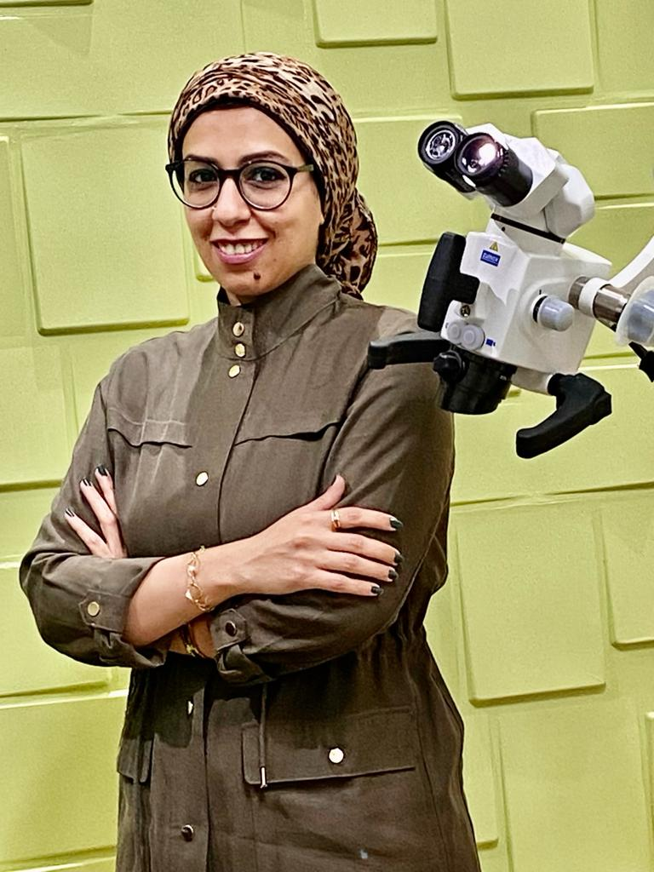image to change picture

